










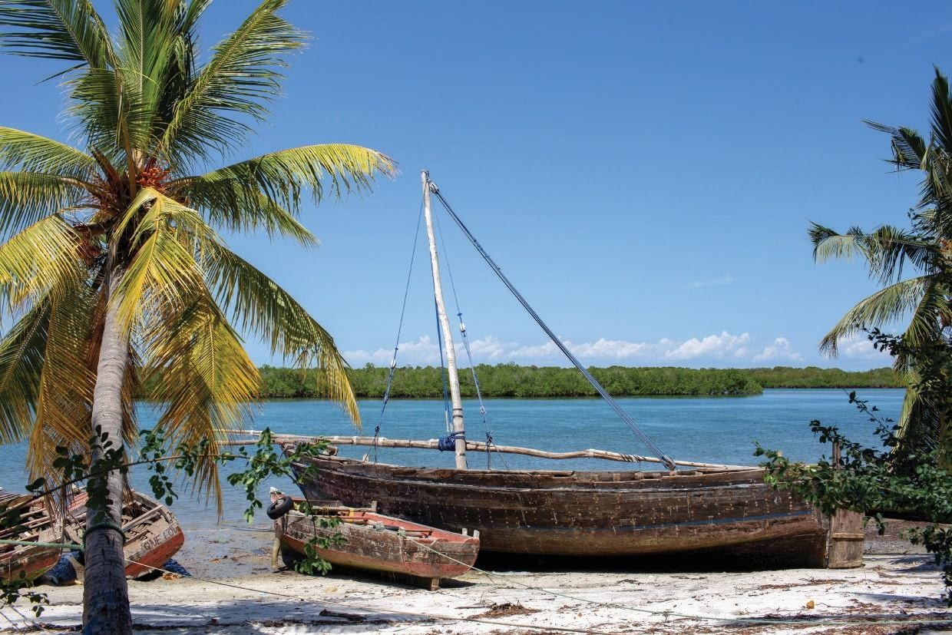

ORGANIZATION PROFILE

“Save the earth”

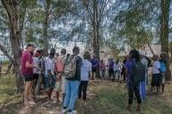
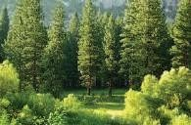
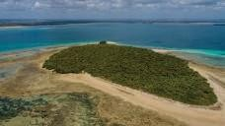
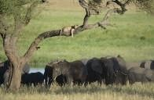
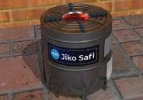
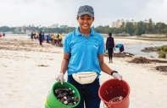

WELCOME
Hello
Welcome to our organization's insights details. This proﬁle gives you an opportunity to know more about the Global Ecology Restoration Foundation. The document will help you to understand our history, our mission, vision, and objectives, and get to know our organization’s focus and thematic areas of work. It also provides highlights of key engaged areas and achievements so far from our activities.
Again, it explains in detail the set of skills our team possesses and can offer to other organizations in accomplishing different project activi- ties and services. Finally, the regions where we are currently focusing and working.
We believe that after going through this proﬁle you will have full
insights into GERF services and activities. Enjoy the reading

Chris Mahundi
Executive Director

Global Ecology Restoration Foundation—GERF.

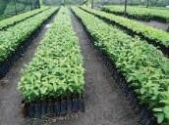
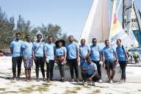
WHO WE ARE
Global Ecology Restoration Foundation – GERF is a non-governmental organization registered in Tanzania with a primary focus on protecting, conserving, managing, and restoring ecosystems.
Founded in 2021 as a community outreach program before being ofﬁ- cially registered on 13th September 2022 with certiﬁcate No 00NGO/R/3780, our main ofﬁce is at Makumbusho, Dar es Salaam. GERF is highly dedicated to conserving lands and water which all life depends. We are guided by scientiﬁc strategies and disciplines in our works, we create and apply innovative ground solutions to our nation’s toughest challenges so that nature and people can thrive together. We partici- pate in tackling climate change challenges, and conserve wild animals, forests, land restorations, fresh waters, and oceans at an unprecedented scale, to provide the best-integrated ecosystem.

MISSION
Championing ecological restoration as the bridge to both heal our planet and enhance human well-being, making it integral to global conservation and sustainable.

VISION
Reviving ecosystems for a harmonious future: where biodiversity thrives, Climates are resilient, nature and culture unites.

OUR OBJECTIVES
To simplify and conjoin the global; conservation, restoration, and educa- tion program.

To engage the community in conservation, restoration, protection, and
education on ecological activities for habitual change and practical.

OUR THEMATIC AREAS
Wildlife
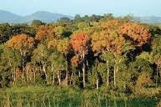
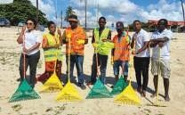
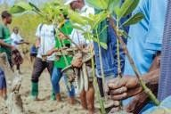
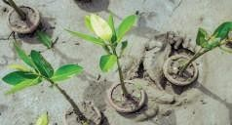
We provide solutions for human-wildlife conﬂicts by adhering to prin- ciples of sustainable conservation that ensure the well-being of wild- life and local communities around protected areas in Tanzania. Our work helps to stop poaching, illegal hunting, snares, and illegal timber works in protected areas.

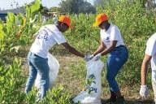
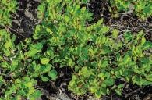
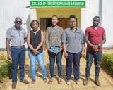
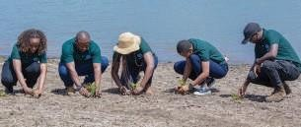
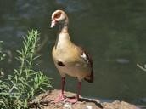
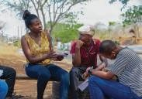

We develop community outreach programs to raise awareness and sensitization towards friendly existing practices with wild animals. These direct engagements include community capacitybuilding and training on wildlife conservation and beneﬁts to the communities.

Forest
We focus on natural and artiﬁcial forest conservation and protection. We support forest and water source conservations by encouraging local communities’ engagement in forest conservation and protection practices.
We advocate environmental awareness and campaigns that help to encourage the wise use of forest resources and create solutions to uplift the well-being of forest resources and water sources and catch- ments.

We advocate and support rural communities in commercial tree
planting and agroforest practices.

Our solutions comprise forest rehabilitation, water catchment areas conservation promotion of land restoration, and community tree planting campaigns

ocean
GERF work to protect our ocean from pollution and illegal exploitation and campaign for ocean safety and health by raising its voice on proper waste management to prevent ocean pollution, especially plastics waste, and illegal ﬁshing.

We work with local communities to restore mangroves and other marine forest species that support the health of marine ecosystems and ecology by providing awareness and capacity building on laws and policies of sustainable ocean use to support local and global marine conservation.

We support and encourage the development of blue economy strategies as part of ocean and marine conservation efforts to uplift the life of coastal communities and maintain a healthy ecosystem.

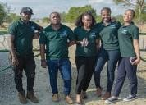
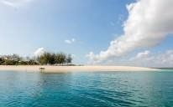
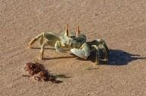
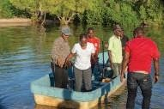
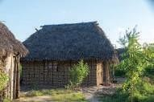
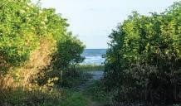

Water
GERF works to protect, conserve and support the wise use of water resources and infrastructure. Our areas of concentration include water source conservation, rehabilitation, and protection in Tanzania. We provide solutions and alternative ways to local communities’ nearby forests and rivers to discourage destruction and water pollution.

We strongly engage to tackle the causes and impacts of climate change that contribute to water scarcity in both rural and urban areas.

We help local communities to understand and practice the wise use of water resources.

Energy
We support clean and renewable energy solutions in both rural and urban areas. We equip the communities with different forms of alter- native energy solutions including solar energy, biogas, wind energy, and improved cook stoves.

In clean cooking energy GERF provides training on the construction of improved cook stoves, especially in rural areas that are affordable and clean.

The imposed stoves support rural communities’ livelihood with clean solutions that reduce pressure on natural forests and trees for wood and charcoal.
Our Solutions are healthy, environmentally, socially, and economical-
ly viable.

GERF’S STRENGTHAND SET OF SKILLS
GERF team of experts provides an equipped set of skills to execute and undertake a different kind of project in different thematic areas. Our Team is made up of experts majoring in various professions. The set of skills includes:
Project Proposal/Concept Note Writing. Project Planning and Management Consultancy
Project Monitoring Research and Survey

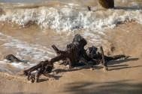
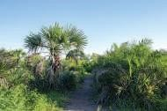
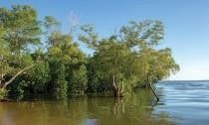
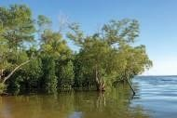
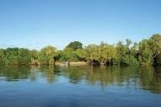
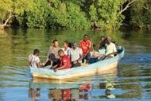

Project Implementation
GERF works in all regions in Tanzania where needs arise, beginning with the following regions
Morogoro Region Pwani Region
Dar es Salaam and Lindi Regions

OUR SUCCESSFUL STORIES

Mangrove restoration at Mdimini village Mkuranga
GERF with collaborative eff¬orts from HUDEFO managed to restore mangroves at Mdimini village Mkuranga DC, with local communities’ awareness of mangroves forest importance and mangroves resto- ration practices and provide training to local communities on how mangroves are important in regulating climate. https://www.instagram.com/p/CgjmootD9o-/?utm_source=ig_web_- copy_link

Bagamoyo ﬁsh market cleaning and handing over sanitation and cleaning equipment
GERF with joint efforts from other organizations participated in the Bagamoyo ﬁsh market and provide environmental awareness train- ing to the local communities and provide them with cleaning and sanitation equipment. https://www.instagram.com/p/CgjkRTljmIG/?utm_source=ig_web_- copy_link

Community empowerment, awareness, and capacity building on the
importance and management of the forest.
GERF engaged in community empowerment, awareness, and capac- ity building on the importance and management of the forest at Mwidu village, and beneﬁts of the station at Mwidu village, and the campaign to plant trees and restore the natural forest.
h t t p s : / / w w w. in s t a gra m . co m / p /C m H F 9 F 1 DG h i / ? u t m _-
source=ig_web_copy_link

Equipping Mkenge Primary School with a Clean water Tank and Fruit tree planting
GERF in collaboration with Kemmon Schools provided environmen- tal awareness education and built a clean water tank for the stu- dents. This project involved fruit tree planting.

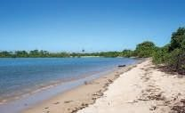
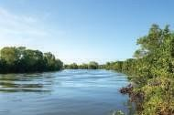
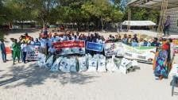
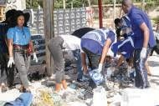
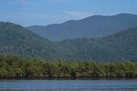
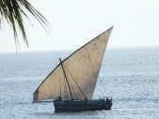

World cleanup day 2022
GERF is an active participant in world cleanup day and in 2022 jointly with the Nipe Fagio organization managed to work on Ocean and Island cleanup at Sinda Island and Rongoni Beach. The project en- gaged local communities to clean the ocean environment and plas- tic waste awareness. https://www.instagram.com/p/CinKBrQjqvb/?utm_source=ig_web_- copy_link https://www.instagram.com/p/CiaHFLcD27P/?utm_source=ig_web_- copy_link

Coco beach boys training on environmental conservation
As part of the community outreach program, GERF provided the Coco beach boys group with beach cleaning equipment and train- ing on how to handle beach waste and the safety of the beachgoers. https://www.instagram.com/p/Cgkf4-1jfWs/?utm_source=ig_web_- copy_link

Earth day commemoration 2023
GERF participated in the 2023 Earth Day commemoration by joining a community of dedicated individuals at Mikoko Seashore to advo- cate for the protection of our planet. The main activity was beach cleanup, team building, games, and providing education on the con- servation, and protection of our planet for a sustainable future. https://www.instagram.com/p/CraD4qdt1dX/?utm_source=ig_web_- copy_link&igshid=MzRlODBiNWFlZA=

Kawe Beach Clean Up 2023
GERF, with other environmental stakeholders participated on Kawe beach cleaning campaign. This initiative aims to ensure a continuous effort to maintain a clean environment and protect Dar es salaam beaches and oceans from plastic and other pollutants.
https://www.instagram.com/p/CxYohGPtvuv/?utm_source=ig_web_copy_link&igsh=MzRlODBiNWFlZA==

Mwananyamala Referral Hospital Community Service 2024
GERF, joined the Kijani Okoa Maisha campaign, a clean-up campaign invited by @kijanika_afrika. It teamed up with other environmental stakeholders and supported the community in various ways; including blood donation, charity donation and distributed tree seedlings. Our goal was to actively engage with the community and contribute to its well-being.
https://www.instagram.com/p/C2ueDsLsY8c/?utm_source=ig_web_copy_link&igsh=MzRlODBiNWFlZA==

Exploring Marine Pollution On Mbudya Island: Beach Clean Up And Waste Segregation 2024
GERF with other environmental stakeholders joined together to embark on a crucial mission to tackle marine pollution head-on. We collected waste and made an assessment afterward making up to 85 % plastic bottles, 80% foam pieces, 52% flip flops & shoes and 21% glass bottles that occurred at short period of time. Through comprehensive waste and brand audits, we highlighted the critical need for enhanced public awareness regarding the destructive impact of marine pollution on our ecosystem.
https://www.instagram.com/p/C7B5kLuNzTU/?utm_source=ig_web_copy_link&igsh=MzRlODBiNWFlZA==

Carbon Trade Capacity Building Training Of Trainers For Small Holders Farmers At Kilolo District, Iringa R 2024
GERF in collaboration with TTGAU (Tanzania Tree Growers Association Union) facilitated a comprehensive capacity building training of trainers on carbon trade. This initiative aimed to empower small tree growers with knowledge and skills necessary to engage effectively in carbon trading.
https://www.instagram.com/p/C81boJNNfoE/?utm_source=ig_web_copy_link&igsh=MzRlODBiNWFlZA==

Driving Renewable Energy Solutions in East Africa 2024
GERF joined hands with a consortium of like-minded organizations to collaborate on initiatives, foster innovation and drive forward renewable energy solutions in East African region.

https://www.instagram.com/p/C9cVjUOtXHX/?utm_source=ig_web_copy_link&igsh=MzRlODBiNWFlZA==

Circular Economy Workshop 2024 (PET Pro): Advancing Sustainability Across Tanzania

GERF attends the PET Pro Workshop, Uniting with stakeholders to drive sustainable impact through collaboration, innovation and unity at the Circular Economy. Together we empower change for a greener future by advocating for refuse, reduce and reuse of plastics.

https://www.instagram.com/p/DCrpS0dNPc7/?utm_source=ig_web_copy_link&igsh=MzRlODBiNWFlZA==

Training Facilitation for Sustainable Energy Solutions for Farmers and Entrepreneurs 2025
Through a successful partnership with Stepmark limited Tanzania, facilitated a transformative workshop on the Productive Use of Solar Energy (PUSE) program in Morogoro. This initiative is to empower farmers and entreprenuers with the knowledge and skills needed to embrace clean energy solutions for a more sustainable future.

https://www.instagram.com/p/DGdAzXiNNB2/?utm_source=ig_web_copy_link&igsh=MzRlODBiNWFlZA==

Launch of Edu-Green Program at Mkenge Primary School 2025

In partnership with The Arts in Tanzania, Association of Tanzanian Water Suppliers (ATAWAS) and the Tanzania Forest Service Agency (TFS). GERF introduces the Edu-Green Project 2025 at Mkenge Primary school in Bagamoyo, Pwani Region. The Establishment of Mali Hai Club in this program; empowers young students to care for trees, emphasizing our commitment to fostering the next generation of environmental sterwards.

https://www.instagram.com/p/DJ_VBhLtqRr/?utm_source=ig_web_copy_link&igsh=MzRlODBiNWFlZA==

Official Launch of the Tanzania Green summit 2025

GERF proudly participated in the Tanzania Green Summit Launch held in Dar es Salaam in July 2025, Joining stakeholders from government, civil society, youth and the private sector to champion environmental sustainability through dialogue innovation and collaboration.

https://www.instagram.com/reel/DLryKi9tbYt/?utm_source=ig_web_copy_link&igsh=MzRlODBiNWFlZA==

Renewable Energy Conference in Nairobi, Kenya 2025

GERF participated in the DREEM Hub/KCIC Renewable Energy Conference in Nairobi, engaging with innovators advancing solar energy in agriculture and rural industries. Lessons from Kenya offer valuable insights for scaling (PUSE) program solutions in Tanzania.

https://www.instagram.com/p/DL7hMtIt71H/?utm_source=ig_web_copy_link&igsh=MzRlODBiNWFlZA==

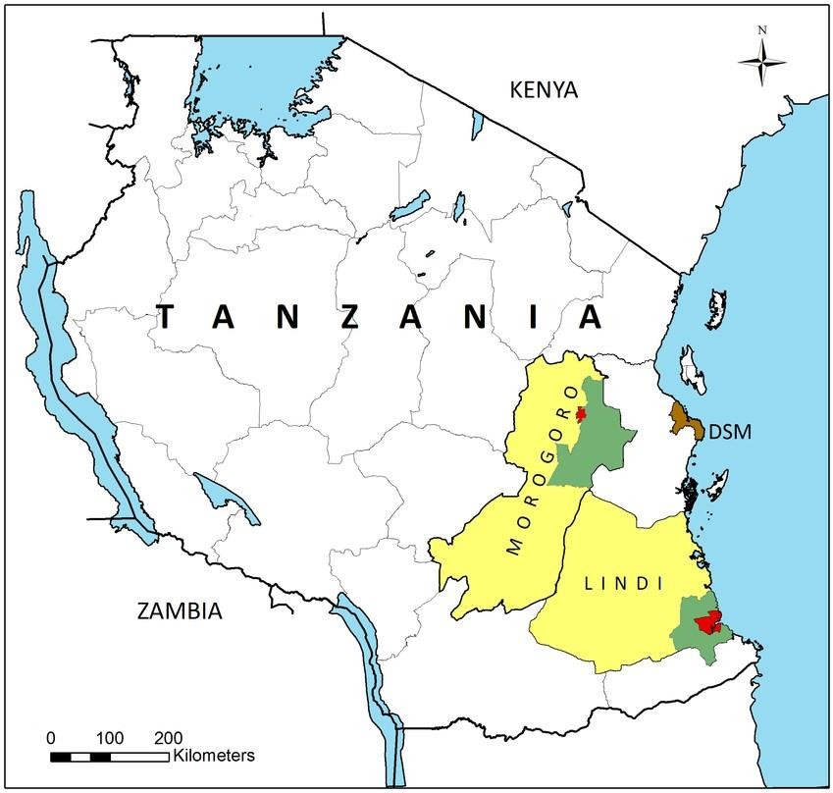
GERF CURRENT ENGAGEMENT AREAS



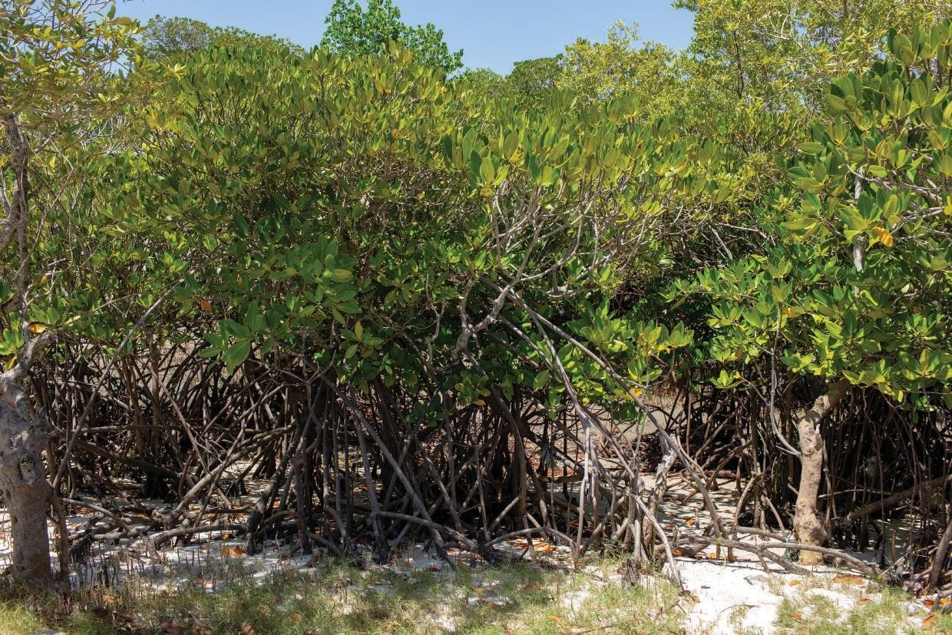




“Save the earth”

